JUnit OUTPUTS

Name : Ganta Sri Ratna Hemanth

Superset id : 6124988

1. Setting Up Junit

**Step 1 :** Create a maven project and select archtypes-quick start.

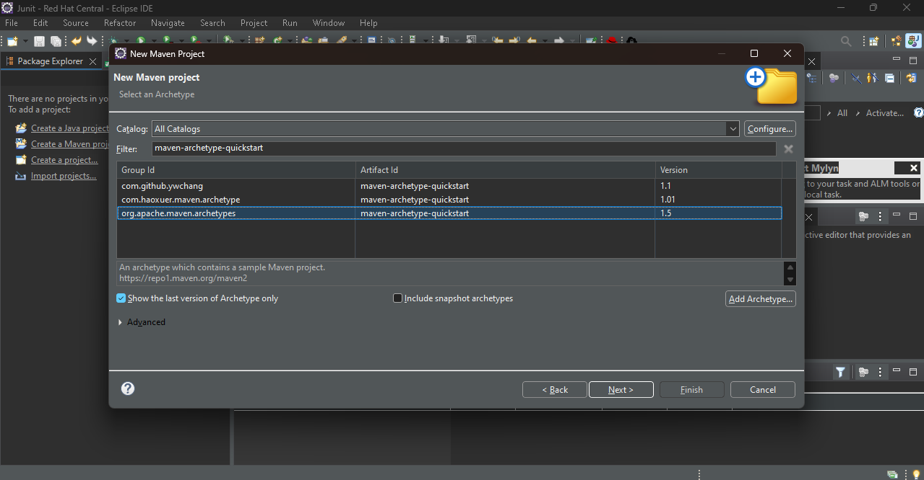

**Step – 2 :** Add this dependency in your pom.xml file

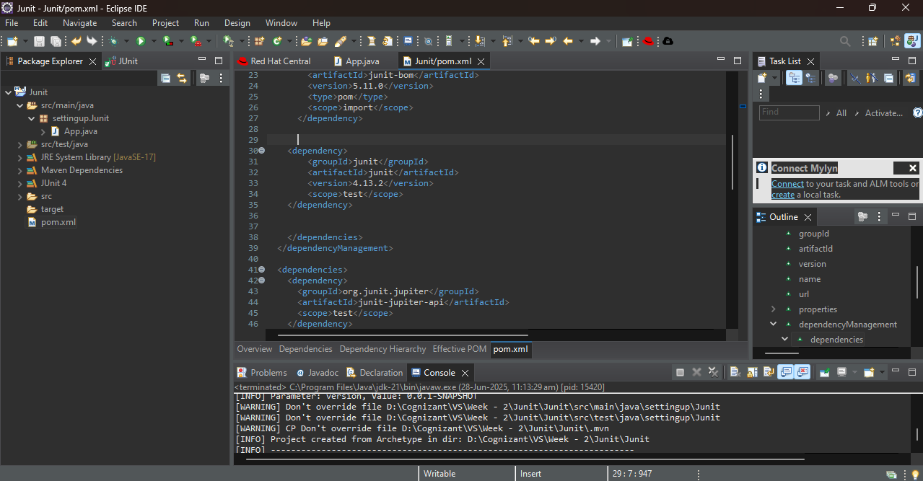

**Step – 3 :** Write a small code to in App.java to test



OUTPUT :

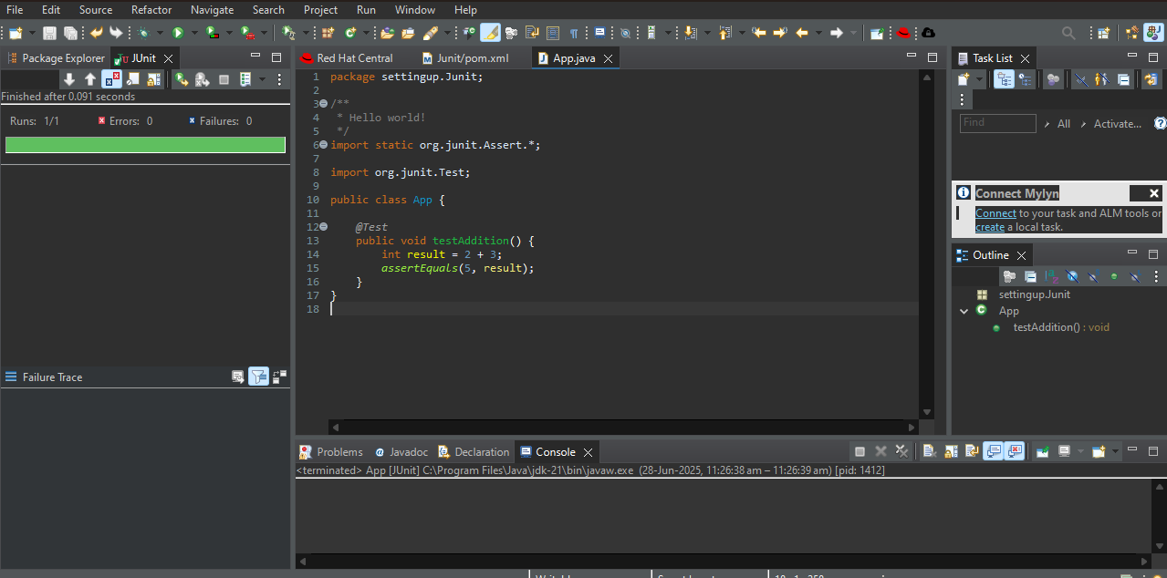

1. Assertions in Junit

**Step – 1 :** Create a maven project and create a class named AssertionsTest and paste the code given in question and run it

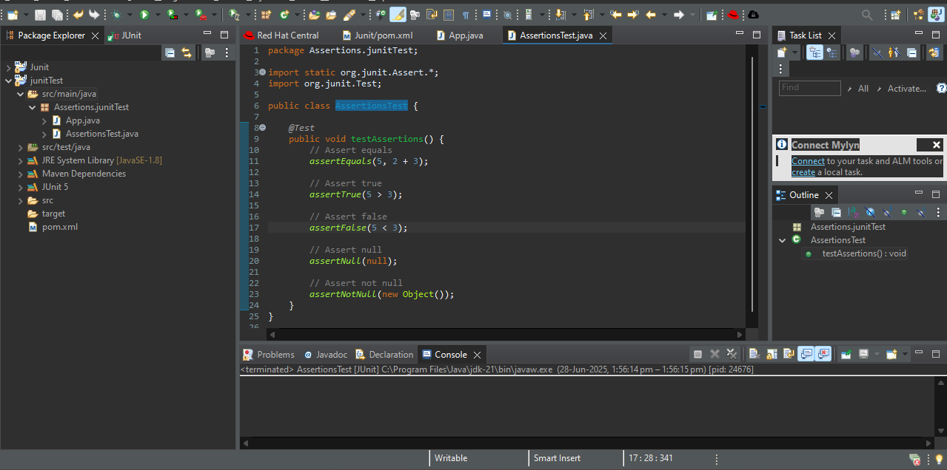

OUTPUT :

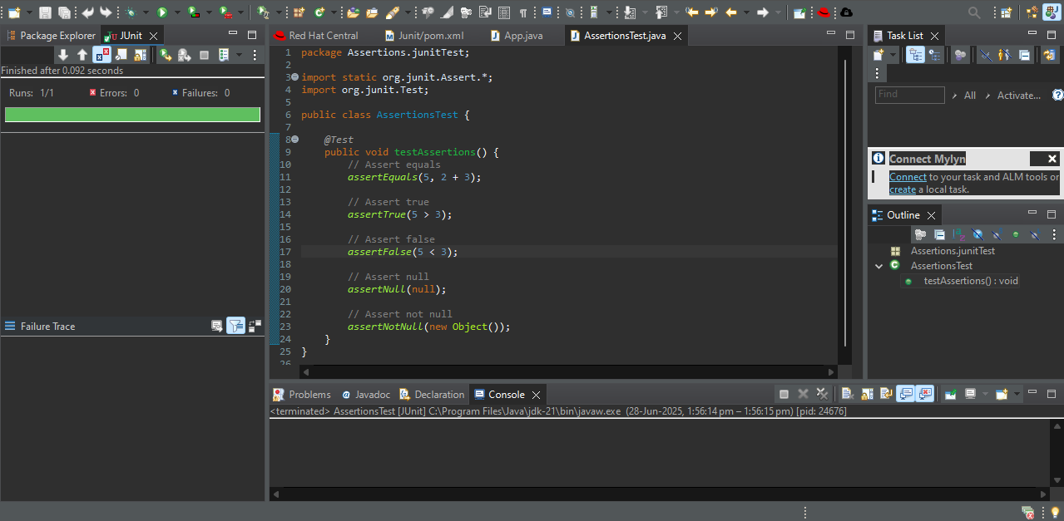

1. Arrange-Act-Assert (AAA) Pattern, Test Fixtures, Setup and Teardown Methods in Junit

**Step – 1 :** Create a maven project and add junit to its dependency in pom.xml file

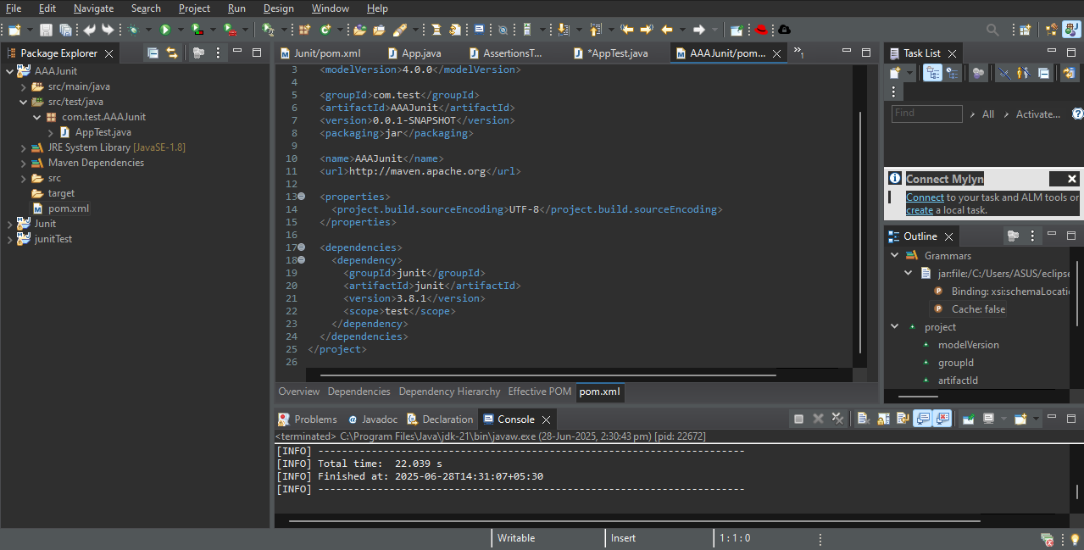

**Step – 2 :** In src/test/java create a class named AAATest

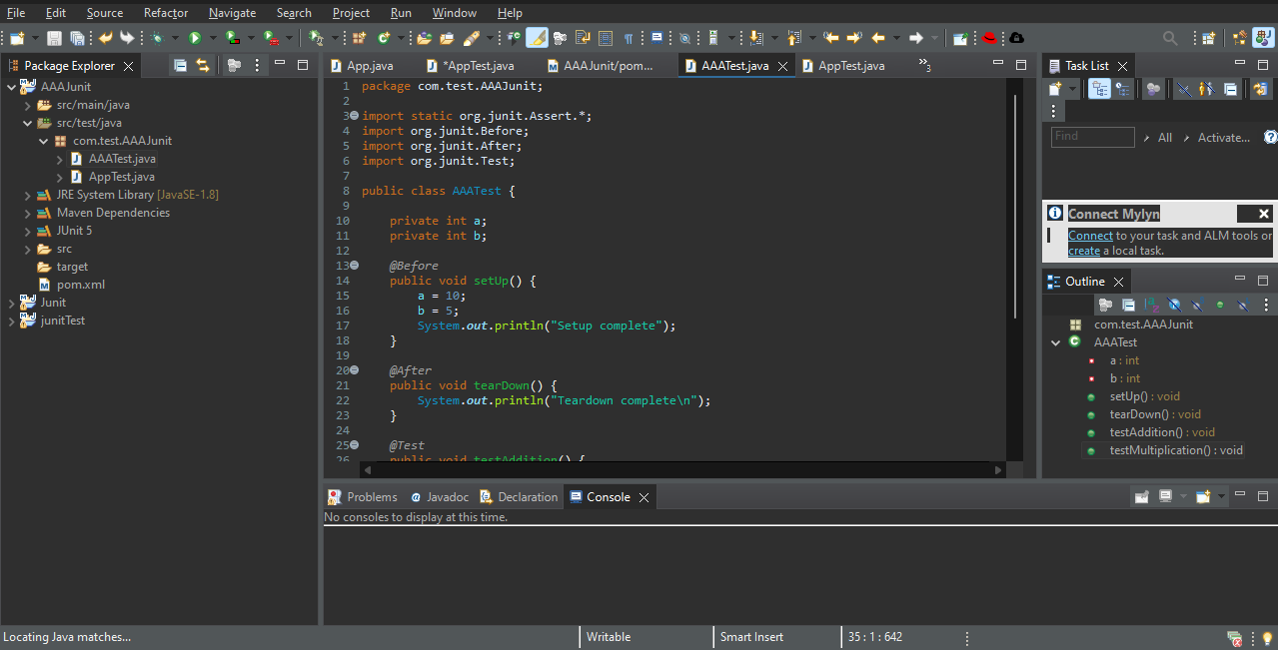

OUTPUT :

